**Ethics Report**

**STP-1**

**Contents**

Introduction 2

Our Concerns 2

Pros 3

Cons 3

GDPR data privacy 3

Considerations 5

Advice 7

Appendix 9

Bibliography 10

# Introduction

In this report we will talk about our concerns surrounding our project. This will mainly concern the privacy of our customers because for our product we will need to collect the stress data of our customers while they play an escape room, and this is personal data. We have also taken a look at the laws that concern us for this project.

# Our Concerns

In order to calibrate our AI on the customers, there will be a need for a baseline. That baseline can be made through a questionnaire or by measuring stress levels before going into the escape room. This does pose the question, what do we do with the data after the customers leave?

For our product we will have to collect sensitive personal biometric data of our customers which will arise some concerns. To get a better idea of our concerns we have made a list of pros and cons on the collection of this data:

## Pros

* We need the live stress data for our product to work.
* We could use the data to increase the accuracy of our AI, without this data the AI can’t grow further and the escape room experience will stagnate.

## Cons

* We collect personal biometric data of our customers, which they might not want.
* The data is visible to the escape room employees, which the customer might not be comfortable with.
* The data could be stolen or misused by those who can access it.
* Not all collected data will increase the accuracy of the AI.

There are a good number of both pros and cons to this problem, so it is important that we come to the right solution. We can only use the data of our customers if they allow us to, and the same goes for keeping the data. This will lead to some customers who would rather not have us use their data at all, therefore they will not be able to use our product since it does not work without the live stress data. However, there will also be customers that will allow us to use their data but not keep it, they will be able to use our product, but our AI will not improve. Yet some customers will allow us to both use and keep their data to improve our AI, we hope that there are enough of such customers for our AI to train on.

For the data we can keep we have to make sure it is not misused or does not spread. We need to store the data in secure databases and the escape room employees have to be held accountable for how they use the data.

# GDPR data privacy

Chapter 3 of the GDPR lays out the data privacy rights and principles that all “natural persons” are guaranteed under EU law. We are obligated to facilitate these rights.

Article 12 — Transparency and communication

We have to explain how we process data in “a concise, transparent, intelligible and easily accessible form, using clear and plain language”. We must also make it easy for people to make requests to us and we will respond to those requests quickly and adequately.

Before the escape room starts we will explain how our product works and how we use the stress data of our customers. We will make this easy to understand for everyone.

Articles 13 & 14 — When collecting personal data

At the moment we collect personal data from a user, we need to communicate specific information to them. If we don’t collect the information directly from the user, we are still required to provide them with similar information. These articles list the exact information we have to provide.

We will make sure that our customers get the right information such as the contact information of the controller for example.

Article 15 — Right of access

Data subjects have the right to know certain information about the processing activities of a data controller. This information includes the source of their personal data, the purpose of processing, and the length of time the data will be held, among other items. Most importantly, they have a right to be provided with their personal data that we are processing.

We will make sure to explain everything to our customers in a way they can understand. After the escape room we will allow them to see their stress data in the form of graphs and our dashboard, which is the same way we and the escape room employees get to see this.

Article 16 — Accuracy

The accuracy of the data we process is only tangentially an aspect of data privacy, but people have a right to correct inaccurate or incomplete personal data that we are processing.

If our customers say that the data is incorrect we will not use it for our AI since this would lower the accuracy of the AI.

Article 17 — Right to erasure

Also known as the “right to be forgotten,” data subjects have the right to request that we delete any information about them that we have. we must make it simple for data subjects to file right to erasure requests.

The customers will be asked if we can keep their data after they are done with the escape room, if not the data will be deleted.

Article 18 — Right to restrict processing

Short of asking us to erase their data, data subjects can request that we temporarily change the way we process their data if they believe the information is inaccurate, is being used illegally, or is no longer needed by the controller for the purposes claimed. The data subject has the right to simply object to us processing of their data as well.

The customers can restrict the way we processes their data, but this will not allow our AI to work. This will lead to them having a normal escape room experience.

Article 20 — Data portability

We have to store our users’ personal data in a format that can be easily shared with others and understood.

The data will be presented in a way the customer can understand it if they see their data.

Article 21 — Right to object

Data subjects have the right to object to us processing their data.

The customers can object to us processing their data, but this will not allow our AI to work. This will lead to them having a normal escape room experience.

(Wolford, 2022)

# Considerations

For our project we need to use personal data of our customers, this raises some ethical problems.

This paper recommends the following actions to be taken in order to adhere to the GDPR laws and to deal with these ethical problems.

We have to:

* make sure we make it clear to our customers how we use the data and why we keep their data.
* make it easy for our customers to tell us if they do not want us to use or keep their data.
* allow our customers to see the data that we use.
* present the data in a way that the customer can easily understand what personal information we use.
* make sure that the data is secure.
* hold the people that use the data accountable for what they do with the data.

# Advice

Process Transparency: A short presentation can make it clear why we’re using their personal data, how we’re using their data and why we keep the data for training purposes. The Costumer can decide via a questionnaire which parts they would allow. Example: We can use their data during the escape room, but we can’t use it to train further or the reverse.

Data Transparency: We can make it clear to the customers what data we use by letting them look into open-source sample data as an example. In that case we can use the same data set for each group, and we’ll not be showing personal data. Additionally, as Article 15 of the GDPR states a Right of access, it's important to assure users they can also access their data after the escape room if they wish to.

Secure data: We can keep the data secure by having it stored on an isolated server and not giving access to it to employees. The AI itself can’t misuse the data and so giving only the AI access to it will keep it safe. The data can then be deleted once its purpose has expired. Also, there is no reason to know from whom the data comes. All data can be made anonymous.

Accountability: Be selective with who has access to the data. The AI provides a recommendation to the escape room operator but there's no reason why the operator should have access to the data. However, within said questionnaire assure users that if they wish to have access to their data

Employee Briefing: Employees should be briefed on the level of access they have to the data; which will be minimal as it’s the AI's job to analyze the data and provide recommendations. The Employees Job is to choose to accept those recommendations, keeping in mind the users behaviors seen through the escapes room cameras.

Customer Choice: To ensure customers feel safe in the environment, first the escape room operator will brief the users in the following order in addition to providing a user-friendly questionnaire (found in Appendix):

1. Introduces the fact that this is an AI based escape room where stress recording wearables will be used if individuals agree and personally wish to. Data will also be collected anonymously to ensure data privacy this needs to be made clear. These wearables are a friendly technology that is there only to help optimise their experience, but they always have the choice to decline.
2. The operator(employee) will also make clear that they themselves can't have access or see the data, all the operator is shown is the stress data dashboard and its recommendations.
3. The participants must fill in a survey (found in Appendix), with questions like: if they are comfortable with the AI using their data during the escape room, how easily they get stressed, if they want their stress levels to be considered for the group average, if they would like the escape room easy or hard and if we can keep the data after they are done with the escape room.
4. The Operator will then inform the users that first a baseline for each participant's stress levels has to be made and that it involves them first sitting in a calm environment and then being shown a slightly scary video.
5. First step in baselining the procedure is having the users sit down, grab a drink and relax(water/coffee/tea)
6. The participants will be shown a calm video that will introduce them to the idea of how their stress will be used in the escape room, after that, the theme of the escape room will be shown, this will be more loud and scary.
7. After the previous actions, the AI will decide the stress thresholds for each participant.
8. The escape room operator will have a short chat with the participants to check how their feeling (check thresholds), and again ask if everyone is 100% comfortable with the information and choices they have been provided with and remind them that scaring someone else on purpose to spike group stress levels to gain hints, will not result in difficulty adjustments.
9. The participants will enter the escape room.
10. While the participants are in the escape room the operator will keep an eye on the dashboard that will show the stress level of each participant and the average stress level of the group. The operator can change the escape room as is necessary. Any purposely stress inducing behaviour. Ie. Someone scaring someone else on purpose to spike group stress levels to gain hints, are ignored.

# Appendix

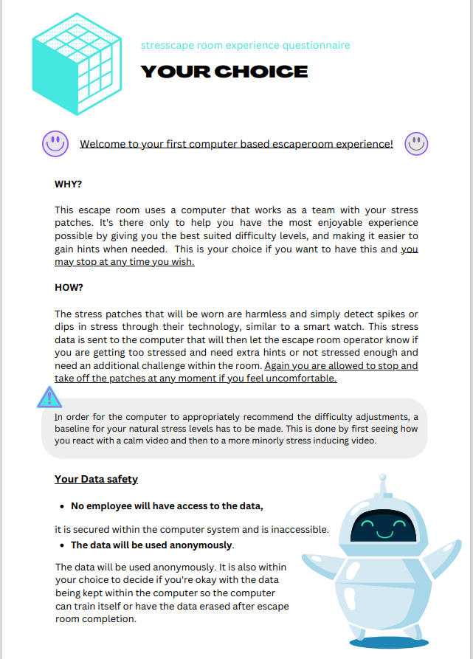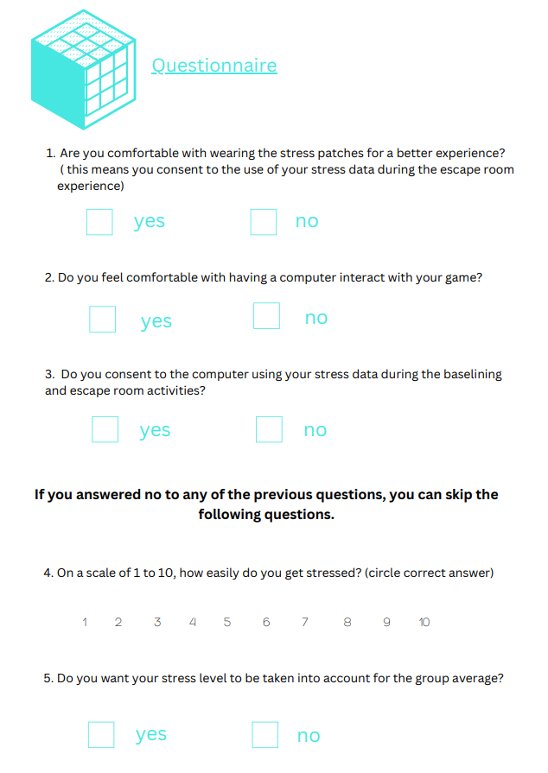

# Bibliography

Wolford, B. (2022). *A guide to GDPR data privacy requirements*. Retrieved from GDPR.EU: https://gdpr.eu/data-privacy/